**Aim of the Experiment:**

The principal objective of this experiment is to fully understand the function and use of logic gates such as7400(quad 2-input NAND gates),7402(quad 2-input NOR gates),7404(Hex inverter) 7408(quad 2-input AND gates) and 7432(quad 2-input OR gates).

**Theory:**

Analysis of Logic gates such as7400(quad 2-input NAND gates),7402(quad 2-input NOR gates),7404(Hex inverter) 7408(quad 2-input AND gates) and 7432(quad 2-input OR gates). The diagram of the chips is shown below:

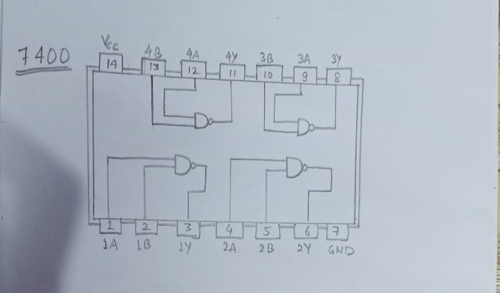  
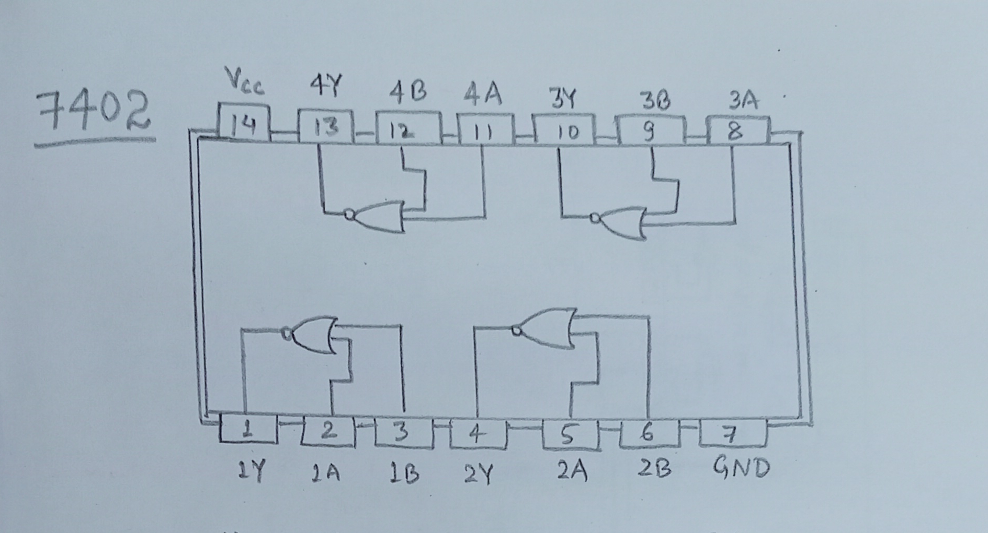

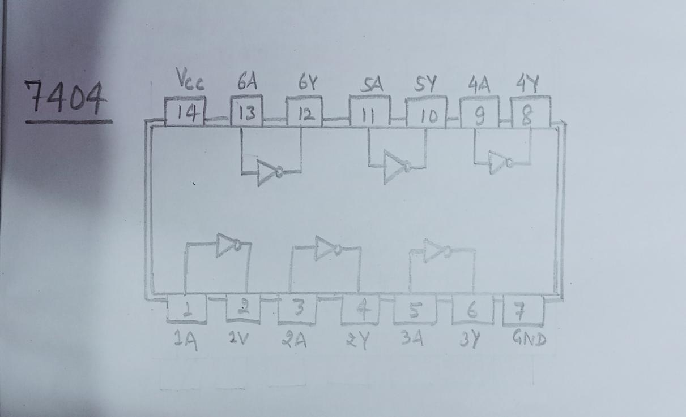 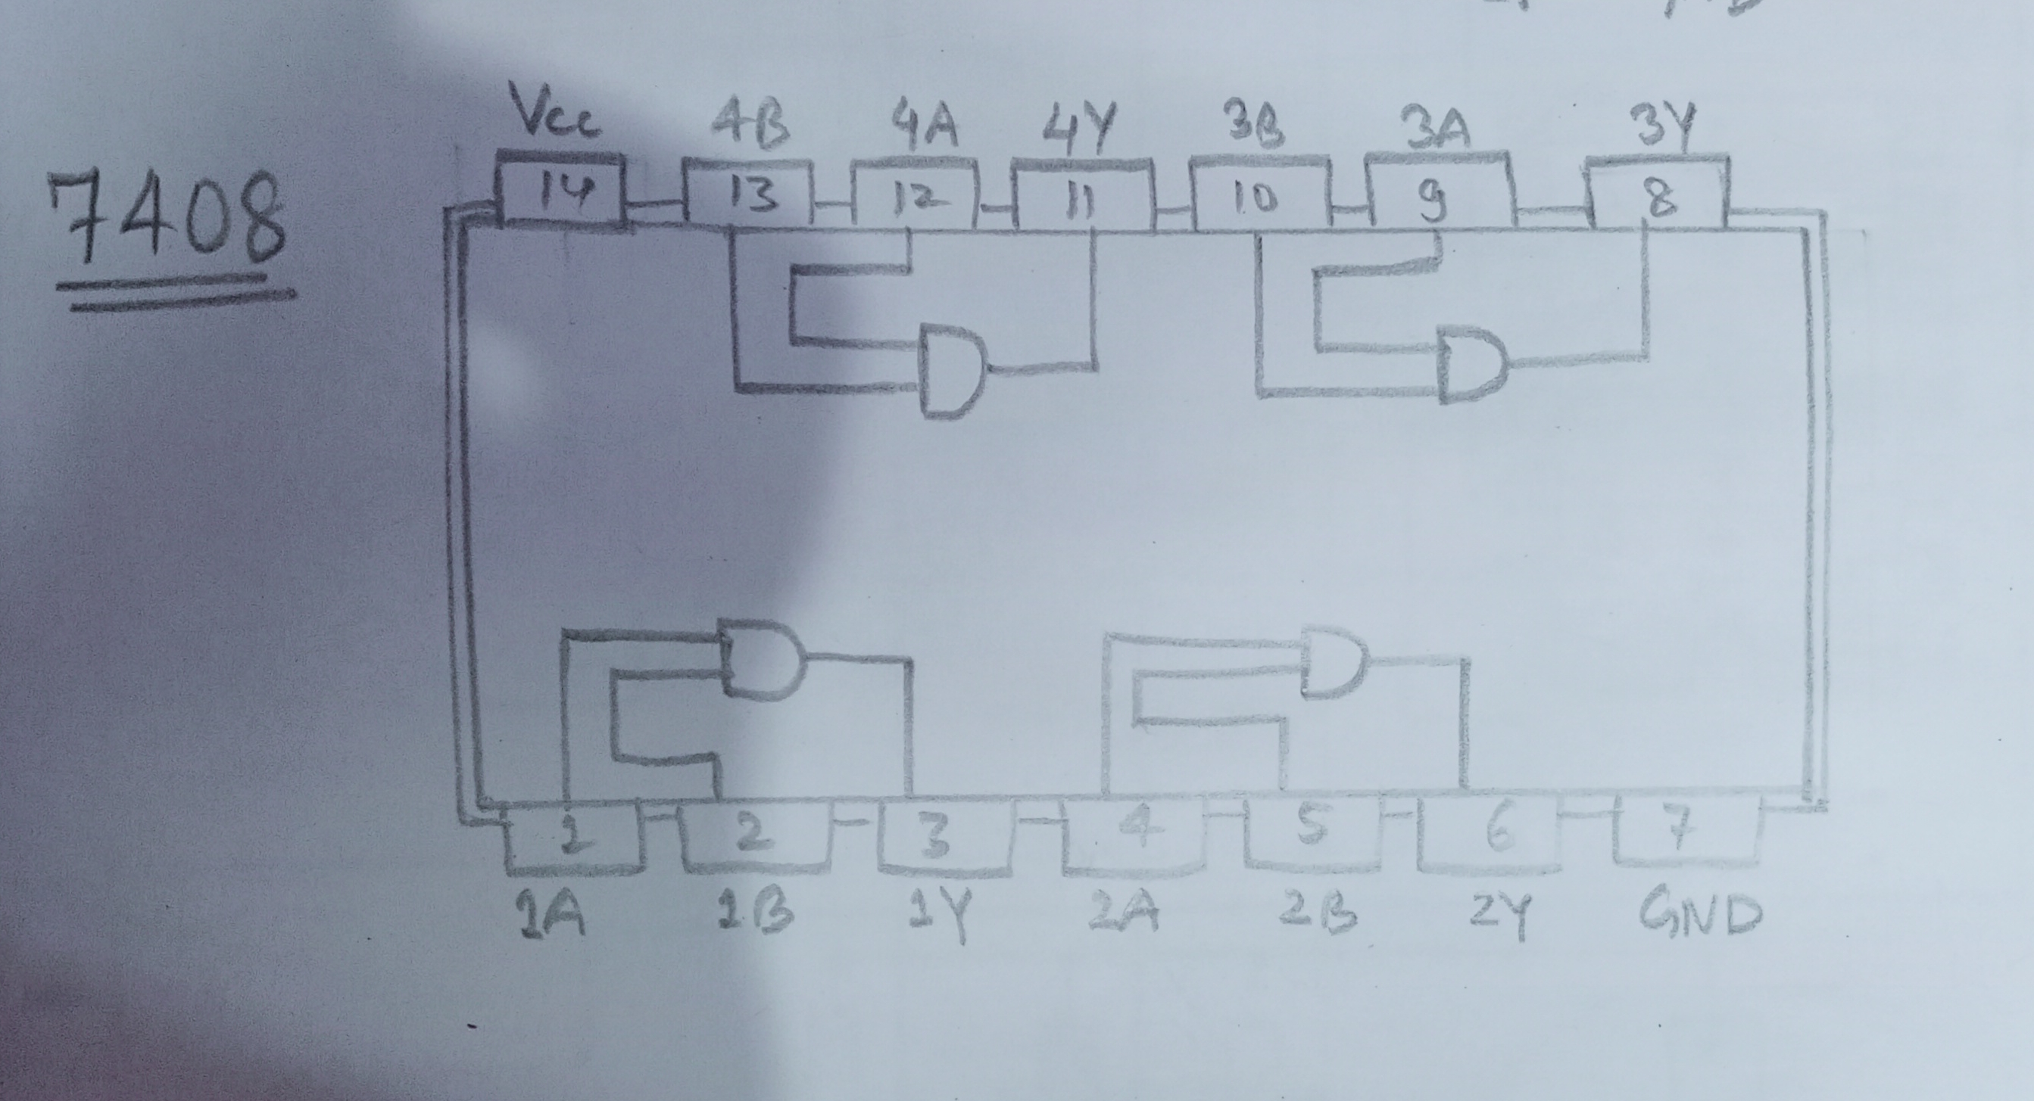

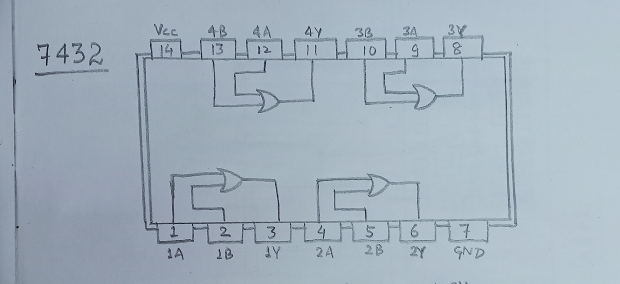

**NOTE: We consider output as 0 for 0V - 0.6V and 1 for 4.2V – 5.0V**

**Components Required:**

1. 7400(quad 2-input NAND gates)

2. 7402(quad 2-input NOR gates)

3. 7404(Hex inverter)

4. 7408(quad 2-input AND gates)

5. 7432(quad 2-input OR gates)

6. 4 Cells

7. Switches

8. LEDs

9.Resistors

10. Connecting Wires

**EXPERIMENT NO. – 1**

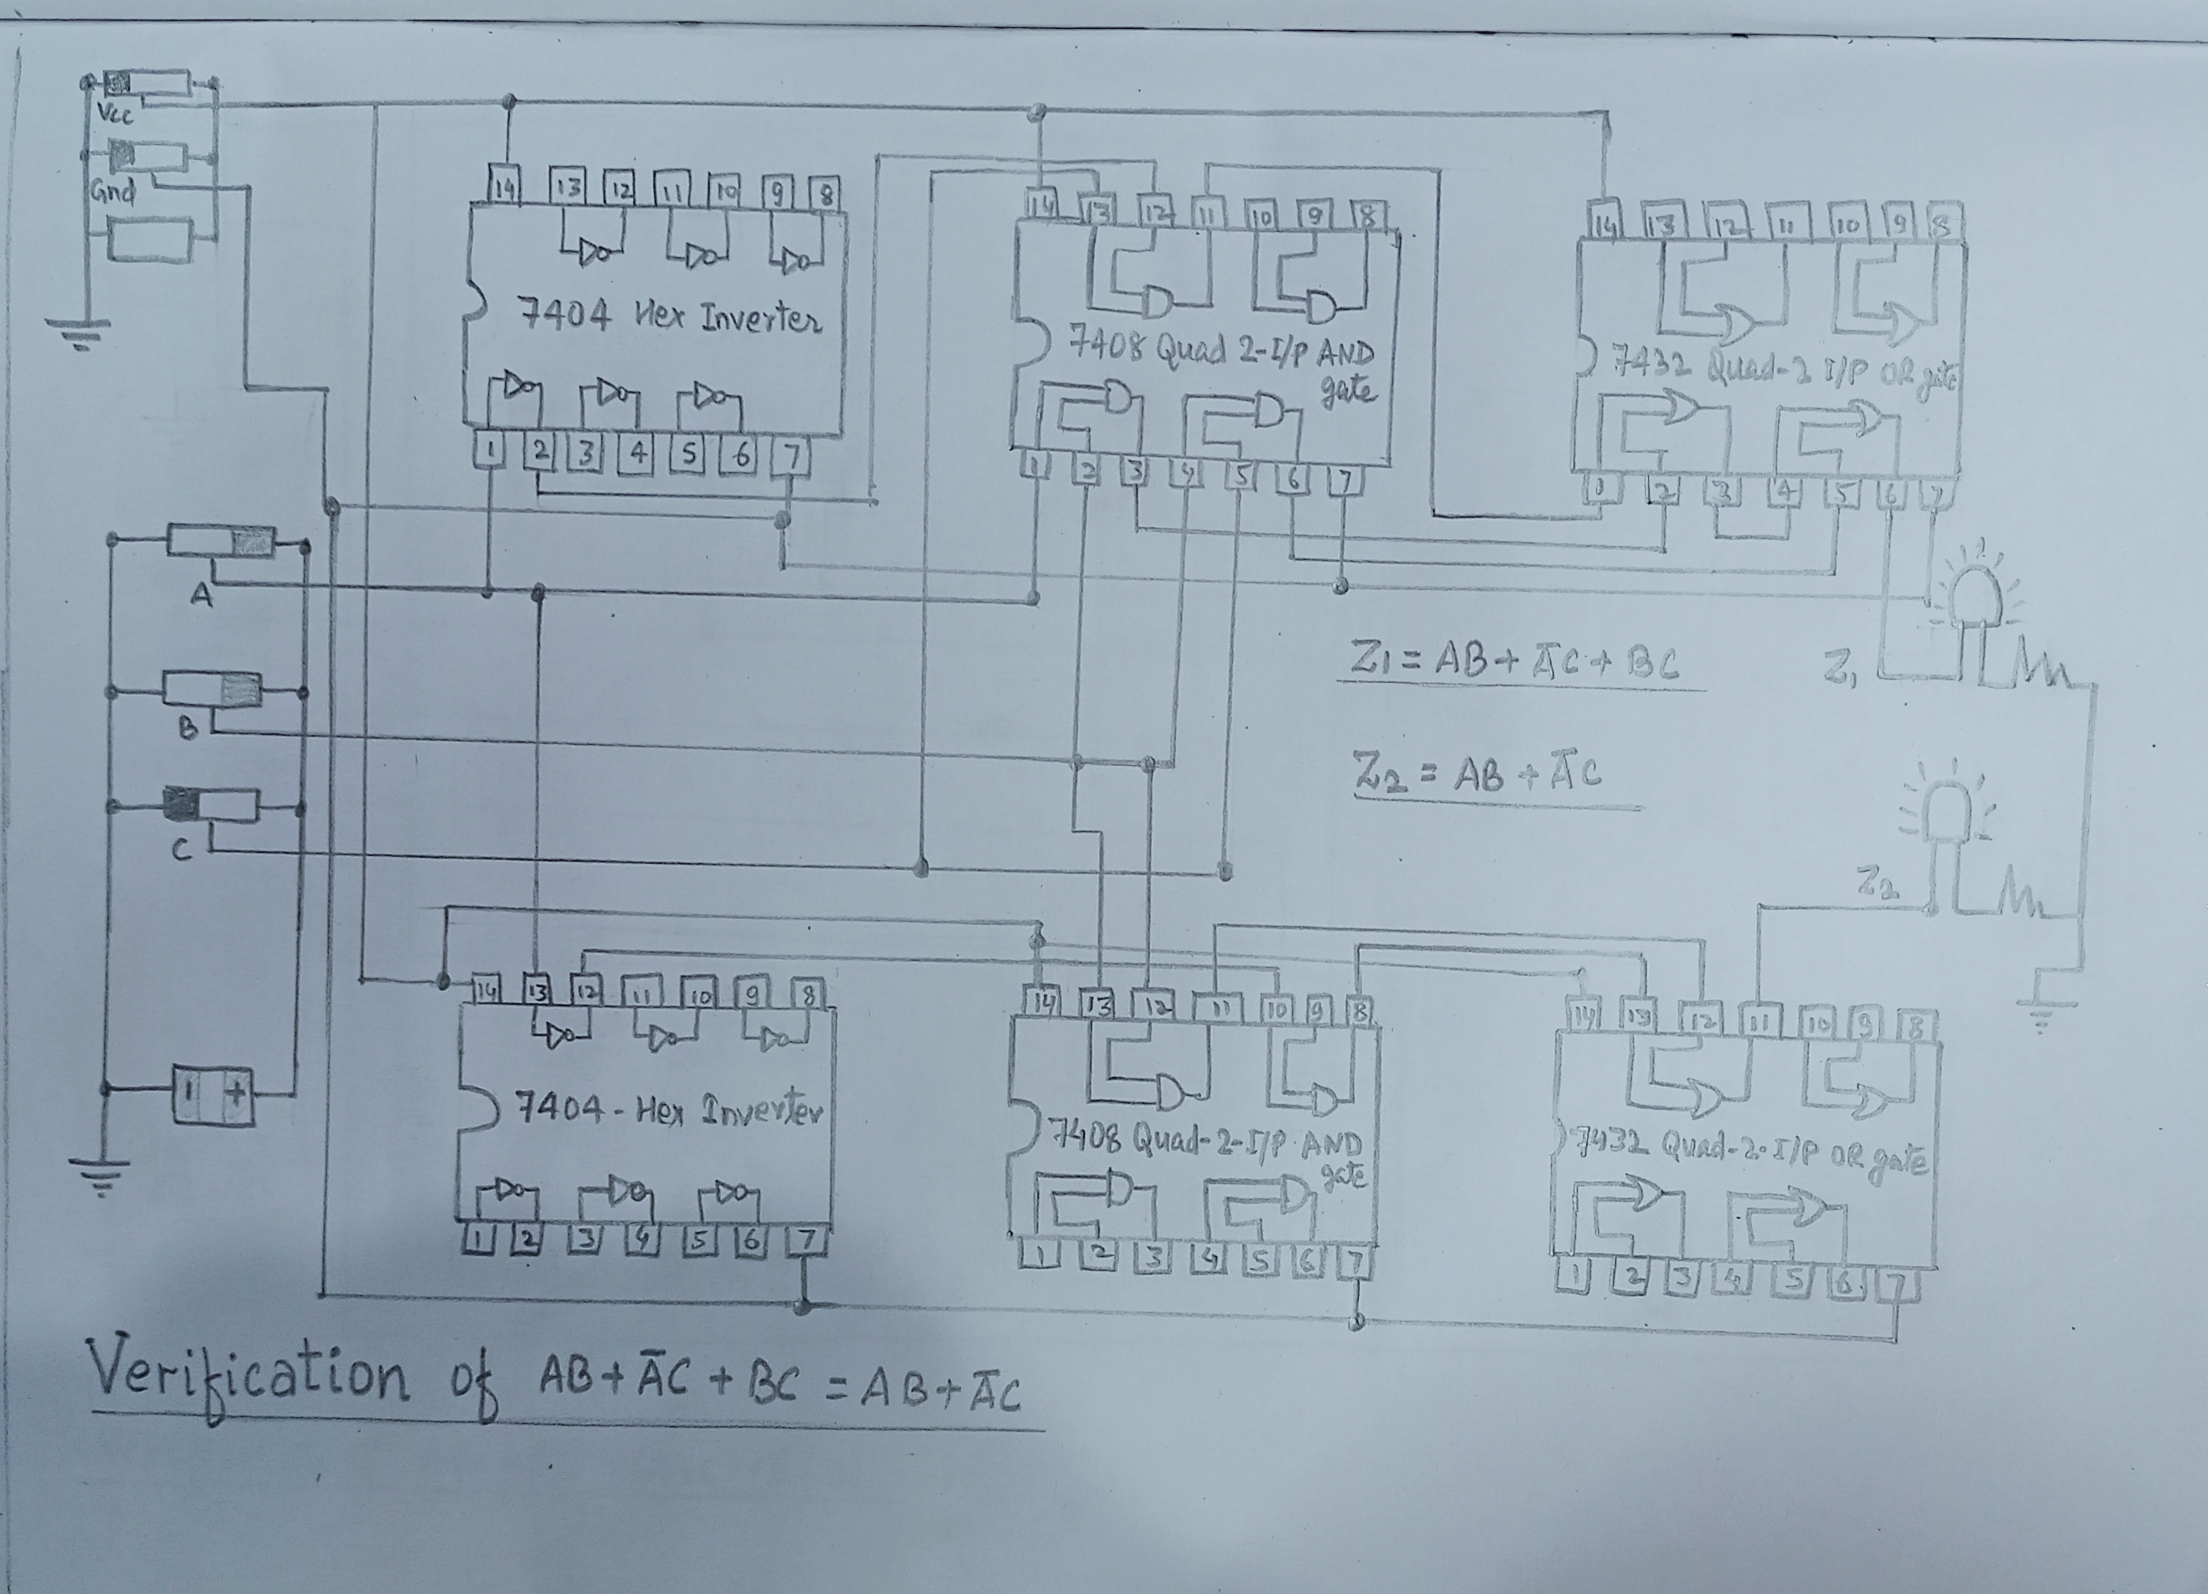

**TRURTH TABLE FOR AB + A’C + BC = AB + A’C**

|  |  |  |  |  |  |  |
| --- | --- | --- | --- | --- | --- | --- |
| **A** | **B** | **C** | **AB + A’C + BC** | **ON / OFF** | **AB + A’C** | **ON / OFF** |
| **0** | **0** | **0** | **0** | **OFF** | **0** | **OFF** |
| **0** | **0** | **1** | **1** | **ON** | **1** | **ON** |
| **0** | **1** | **0** | **0** | **OFF** | **0** | **OFF** |
| **0** | **1** | **1** | **1** | **ON** | **1** | **ON** |
| **1** | **0** | **0** | **0** | **OFF** | **0** | **OFF** |
| **1** | **0** | **1** | **0** | **OFF** | **0** | **OFF** |
| **1** | **1** | **0** | **1** | **ON** | **1** | **ON** |
| **1** | **1** | **1** | **1** | **ON** | **1** | **ON** |

**EXPERIMENT NO. - 2**

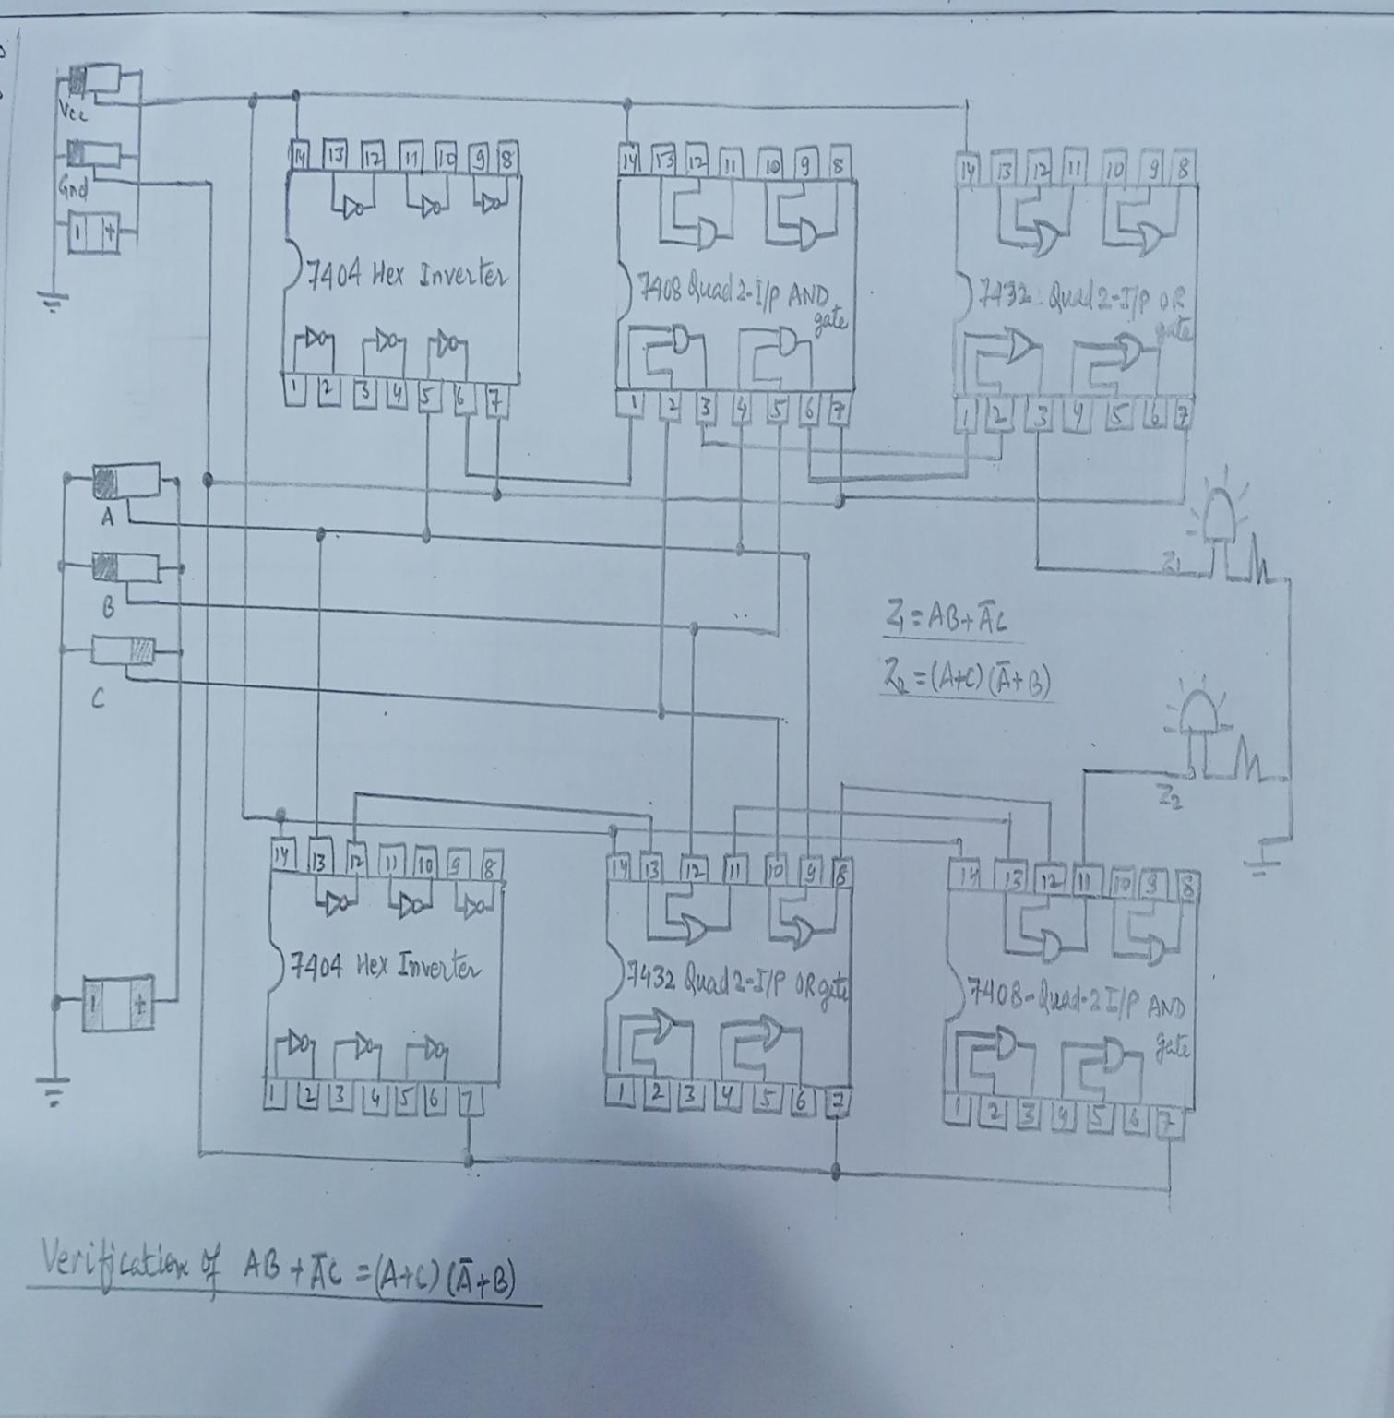

**TRUTH TABLE FOR AB + A’C = (A +B )(A’ + C)**

|  |  |  |  |  |  |  |
| --- | --- | --- | --- | --- | --- | --- |
| **A** | **B** | **C** | **AB + A’C** | **ON / OFF** | **(A + B)(A’ + C)** | **ON / OFF** |
| **0** | **0** | **0** | **0** | **OFF** | **0** | **OFF** |
| **0** | **0** | **1** | **1** | **ON** | **1** | **ON** |
| **0** | **1** | **0** | **0** | **OFF** | **0** | **OFF** |
| **0** | **1** | **1** | **1** | **ON** | **1** | **ON** |
| **1** | **0** | **0** | **0** | **OFF** | **0** | **OFF** |
| **1** | **0** | **1** | **0** | **OFF** | **0** | **OFF** |
| **1** | **1** | **0** | **1** | **ON** | **1** | **ON** |
| **1** | **1** | **1** | **1** | **ON** | **1** | **ON** |

**EXPERIMENT NO. - 3**

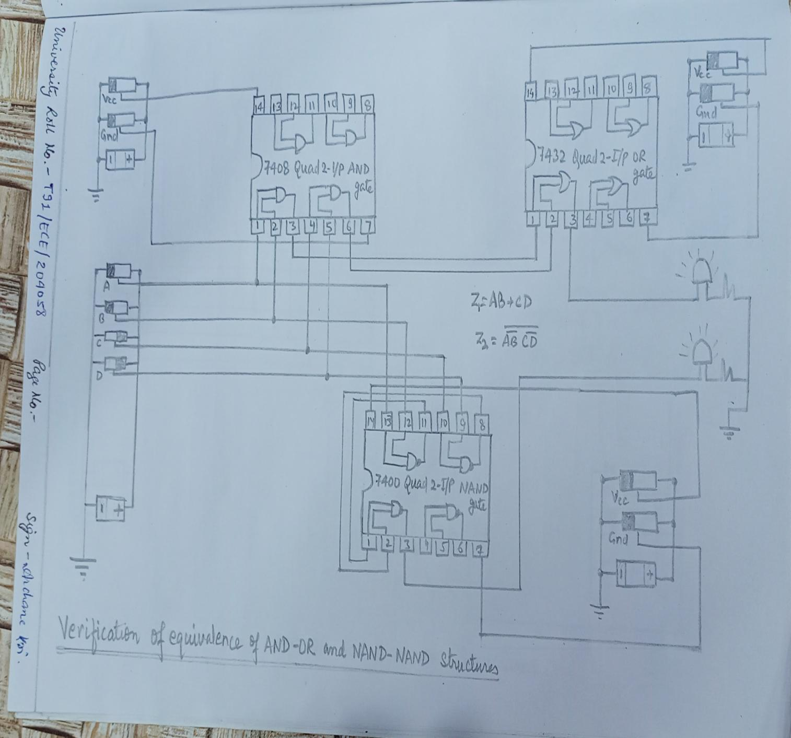

**TRUTH TABLE FOR AB + CD = (A’B ’ + C’D’)’**

|  |  |  |  |  |  |  |  |
| --- | --- | --- | --- | --- | --- | --- | --- |
| **A** | **B** | **C** | **D** | **AB + CD** | **ON/OFF** | **(A’B’ + C’D’)’** | **ON/OFF** |
| **0** | **0** | **0** | **0** | **0** | **OFF** | **0** | **OFF** |
| **0** | **0** | **0** | **1** | **0** | **OFF** | **0** | **OFF** |
| **0** | **0** | **1** | **0** | **0** | **OFF** | **0** | **OFF** |
| **0** | **0** | **1** | **1** | **1** | **ON** | **1** | **ON** |
| **0** | **1** | **0** | **0** | **0** | **OFF** | **0** | **OFF** |
| **0** | **1** | **0** | **1** | **0** | **OFF** | **0** | **OFF** |
| **0** | **1** | **1** | **0** | **0** | **OFF** | **0** | **OFF** |
| **0** | **1** | **1** | **1** | **1** | **ON** | **1** | **ON** |
| **1** | **0** | **0** | **0** | **0** | **OFF** | **0** | **OFF** |
| **1** | **0** | **0** | **1** | **0** | **OFF** | **0** | **OFF** |
| **1** | **0** | **1** | **0** | **0** | **OFF** | **0** | **OFF** |
| **1** | **0** | **1** | **1** | **1** | **ON** | **1** | **ON** |
| **1** | **1** | **0** | **0** | **1** | **ON** | **1** | **ON** |
| **1** | **1** | **0** | **1** | **1** | **ON** | **1** | **ON** |
| **1** | **1** | **1** | **0** | **1** | **ON** | **1** | **ON** |
| **1** | **1** | **1** | **1** | **1** | **ON** | **1** | **ON** |

**EXPERIMENT NO. - 4**

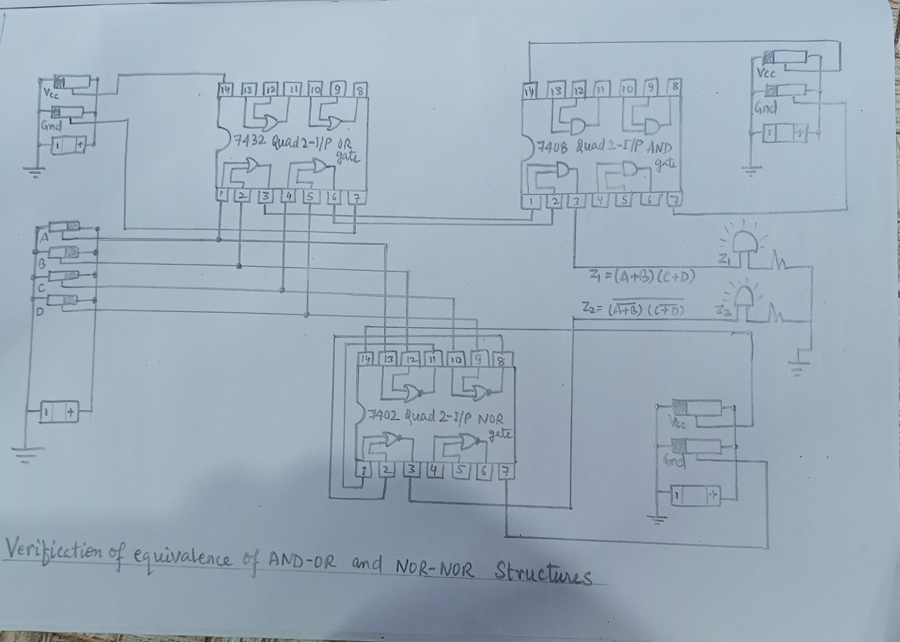

**TRUTH TABLE FOR (A + B)(C + D) = ((A’ +B ’)(C’ + D’))’**

|  |  |  |  |  |  |  |  |
| --- | --- | --- | --- | --- | --- | --- | --- |
| **A** | **B** | **C** | **D** | **(A+B) (C+D)** | **ON/OFF** | **((A’+B’)(C’+D’))’** | **ON/OFF** |
| **0** | **0** | **0** | **0** | **0** | **OFF** | **0** | **OFF** |
| **0** | **0** | **0** | **1** | **0** | **OFF** | **0** | **OFF** |
| **0** | **0** | **1** | **0** | **0** | **OFF** | **0** | **OFF** |
| **0** | **0** | **1** | **1** | **0** | **OFF** | **0** | **OFF** |
| **0** | **1** | **0** | **0** | **0** | **OFF** | **0** | **OFF** |
| **0** | **1** | **0** | **1** | **1** | **ON** | **1** | **ON** |
| **0** | **1** | **1** | **0** | **1** | **ON** | **1** | **ON** |
| **0** | **1** | **1** | **1** | **1** | **ON** | **1** | **ON** |
| **1** | **0** | **0** | **0** | **0** | **OFF** | **0** | **OFF** |
| **1** | **0** | **0** | **1** | **1** | **ON** | **1** | **ON** |
| **1** | **0** | **1** | **0** | **1** | **ON** | **1** | **ON** |
| **1** | **0** | **1** | **1** | **1** | **ON** | **1** | **ON** |
| **1** | **1** | **0** | **0** | **0** | **OFF** | **0** | **OFF** |
| **1** | **1** | **0** | **1** | **1** | **ON** | **1** | **ON** |
| **1** | **1** | **1** | **0** | **1** | **ON** | **1** | **ON** |
| **1** | **1** | **1** | **1** | **1** | **ON** | **1** | **ON** |